## **Project Two: Animal Shelter**

*This application allows you to view the data within the AAC database in an easy to use way with many different filter options to find which animal you would like to narrow down to.*

## **Motivation**

*This project is to learn how to access and change data inside a database using Python and Mongo*

## **Getting Started**

*Download the AnimalShelter.py and the Project2.ipynb files*

*-Open a terminal and import the csv file of your choice*

*-Make an aacuser account to access database*

*-Open Jupyter Notebook and run Project2.ipynb*

## **Installation**

*Install latest version of Python (Jupyter Notebook) from their website*

*Install mongosh through the terminal*

*Install Dash*

*Ensure the port number is correct*

## **Usage**

*Use this space to show useful examples of how your project works and how it can be used. Be sure to include examples of your code, tests, and screenshots.*

### **Code Example**

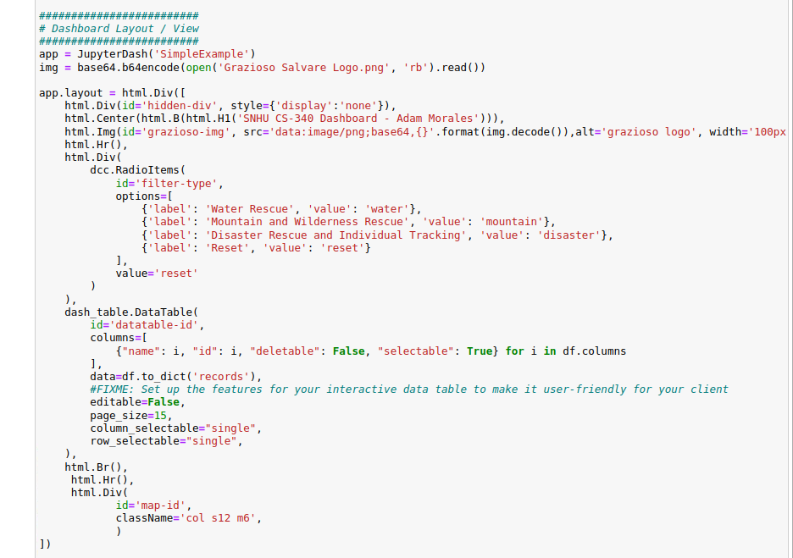

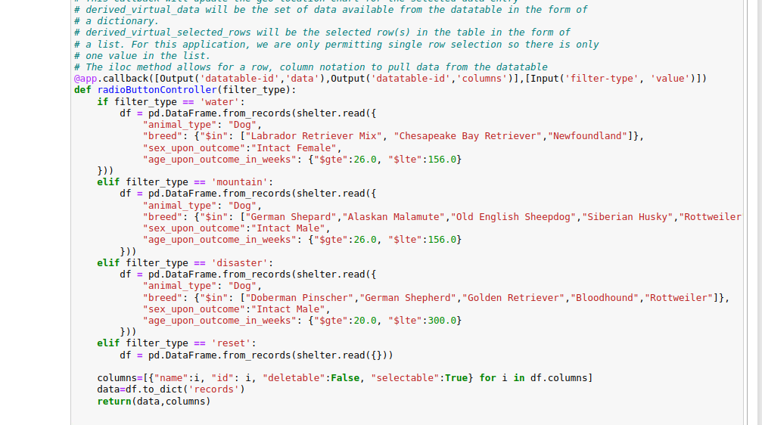

Running Dash:  
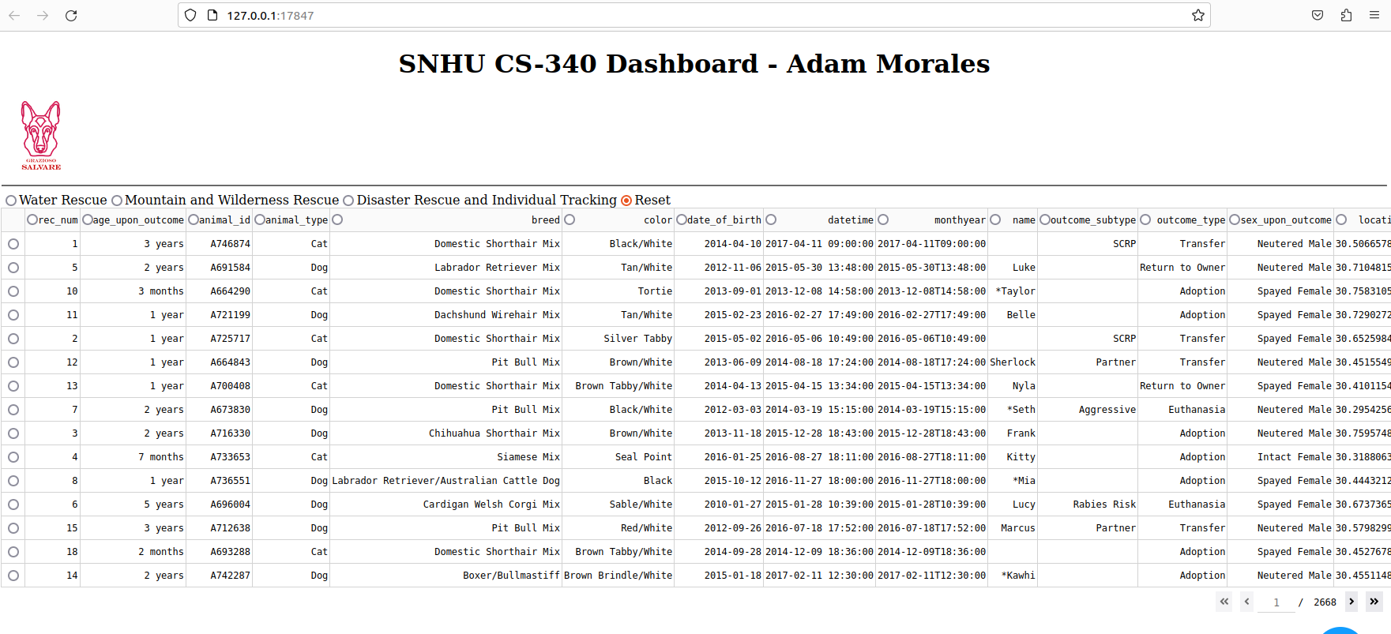

Working Radio buttons:

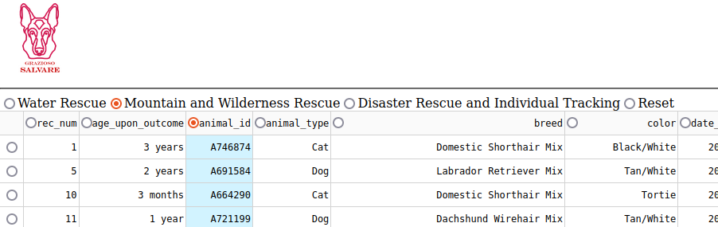

Changing options and switches Geolocation:  
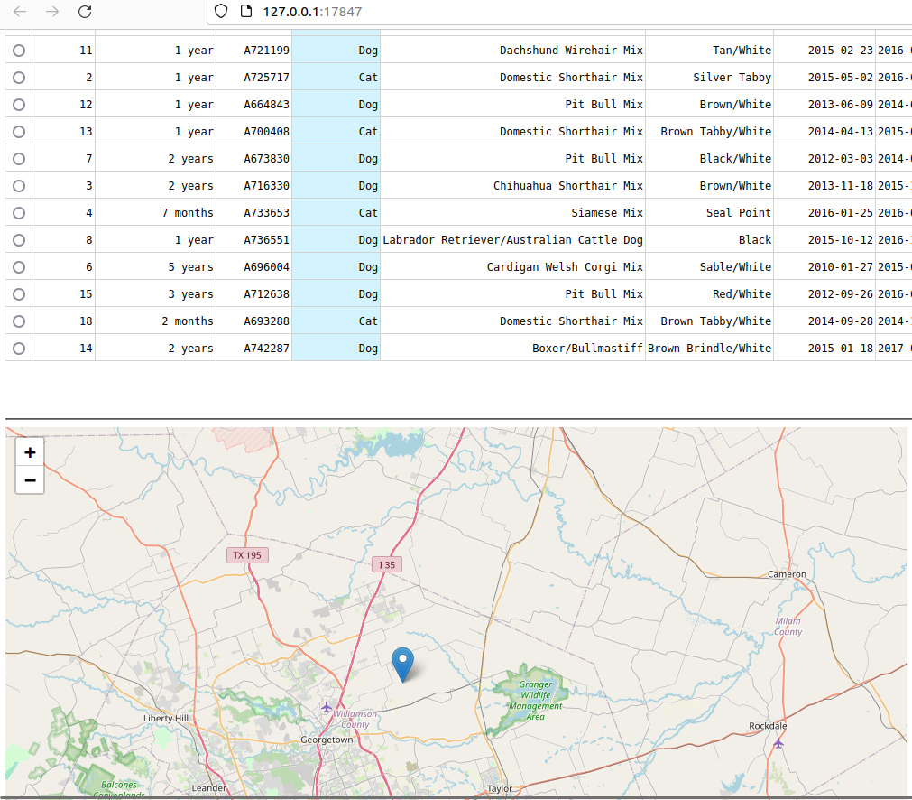

**Errors:**

**Ran into many errors with Jupyter. All code ran fine until I restarted the notebook and it stopped running altogether. Had to restart Jupyter many times without even changing code for it to work again.**

## **Contact**

Adam Morales